1.5 I can follow instructions and act accordingly to requests

At the beginning of my course our tutor explained to us that we would be creating our own website. The tutor instructed us to come up with an idea for our website and create a webpage wire diagram which I completed as below;

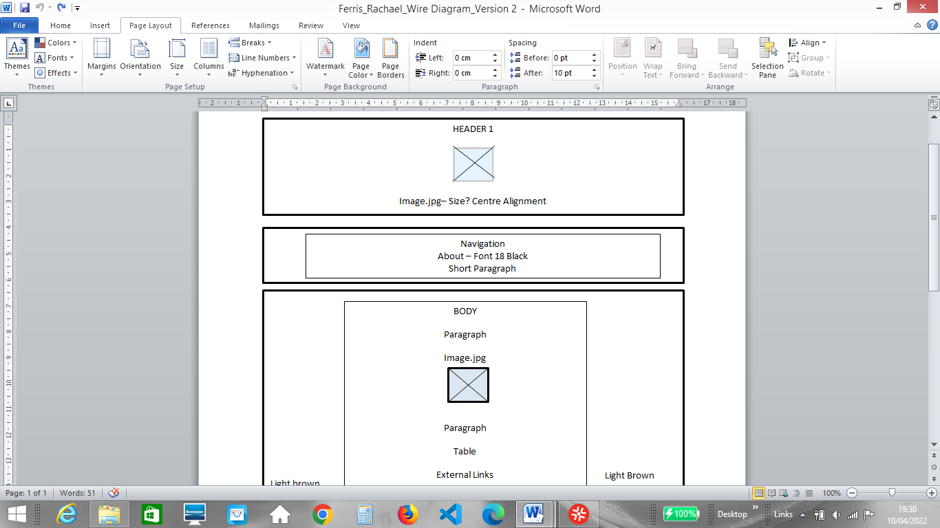

I followed the Tutor’s instructions to download/upload a source code editor from a number of options including Visual Studio Code, Sublime Text and Notepad, deciding on Visual Studio Code as the best option for me. The tutor requested that we take the time to learn some HTML using the W3 website so that we could create a basic framework as a starting point for the creation of our website. I used the W3 website to learn the HTML needed to start creating my website, also using additional resources to expand my knowledge further.

As part of the course I have been required to work collaboratively on tasks with other course members. One task required us to use Microsoft teams to hold a meeting to present a PowerPoint presentation on a topic of our choice. I presented my PowerPoint to the group, choosing coffee as my topic for discussion following the instructions from the tutor to present clearly, be informative and to use the tools within PowerPoint such as animations and graphics to keep the audience engaged. The Tutor instructed us to complete a peer observation worksheet to give feedback that would help my fellow students improve on their presentation skills which I completed for each presentation and I used the feedback categories to reflect on my own presentation e.g. spelling and grammar, structure of presentation. The task required me to contribute by asking the presenter questions, actively listening and giving constructive feedback.

My tutor has instructed us to upload our work onto Git Hub partly to help us keep track of what we have done. I have set up a Git Hub account and I have uploaded my work onto the website. I do need to improve my organisation skills in regards to this I do forget to add newly completed assignments. Using Git hub to fulfil this requirement has required me to research how to use the website as there are numerous elements and terminology that I am not familiar with such as ‘commits’ and ‘branches’.

